

AI in HealthTech

Use Cases of AI in Healthtech



-By
Shivam Kumar Giri

There are numerous applications of AI in healthcare, but three most important ones are: -

PREDICTIVE ANALYSIS OF CHRONIC DISEASE
AI can help to identify most of the deadly and dangerous diseases know its extent can easily help in early detection of the diseases. This include cancers, tumors, AIDS, and Even Covid-19 for early detection and ease the cure, it can also be used for predicting heart disease, predict Diabetes based on the test history. It can also detect the genetically transmitted diseases.
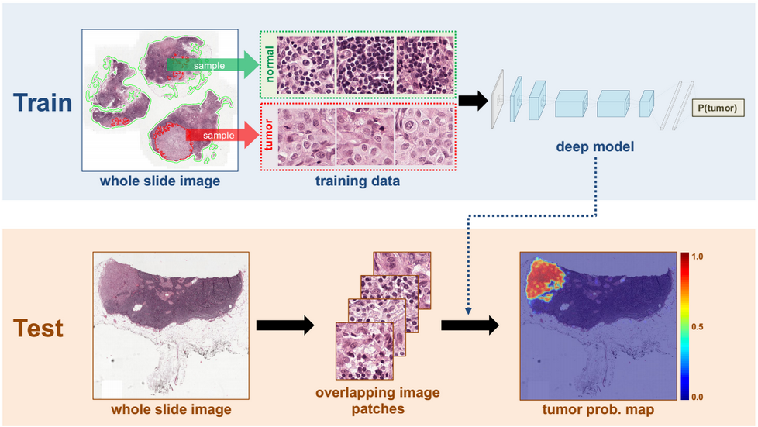

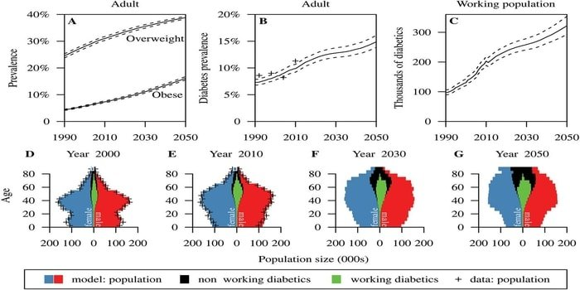

IBM Watson Genomics is a prime example of how integrating cognitive computing with genome-based tumor sequencing can help in making a fast diagnosis. Berg, the biopharma giant is leveraging AI to develop therapeutic treatments in areas such as oncology. P1vital's PReDicT (Predicting Response to Depression Treatment) aims to develop a commercially feasible way to diagnose and provide treatment in routine clinical conditions.

PERSONALIZED MEDICINE
Personalized treatments can not only be more effective by pairing individual health with predictive analytics but is also ripe are for further research and better disease assessment. Currently, physicians are limited to choosing from a specific set of diagnoses or estimate the risk to the patient based on his symptomatic history and available genetic information.

Machine learning in medicine is making great strides, and IBM Watson Oncology is at the forefront of this movement by leveraging patient medical history to help generate multiple treatment options. In the coming years, we will see more devices and biosensors with sophisticated health measurement capabilities hit the market, allowing more data to become readily available for such cutting-edge ML-based healthcare technologies.
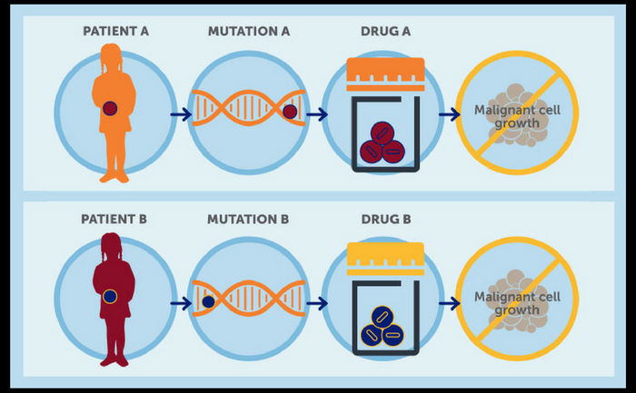
DRUG DISCOVERY AND MANUFACTURING
One of the primary clinical applications of machine learning lies in early-stage drug discovery process. This also includes R&D technologies such as next-generation sequencing and precision medicine which can help in finding alternative paths for therapy of multifactorial diseases. Currently, the machine learning techniques involve unsupervised learning which can identify patterns in data without providing any predictions.
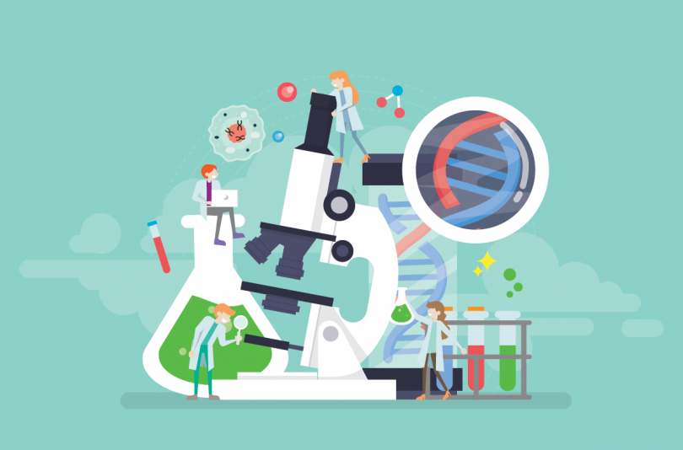
Project Hanover developed by Microsoft is using ML-based technologies for multiple initiatives including developing AI-based technology for cancer treatment and personalizing drug combination for AML (Acute Myeloid Leukemia).
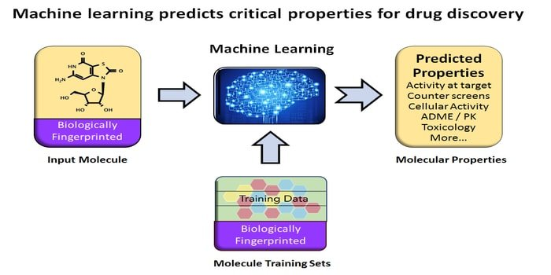
CONCLUSION
Artificial intelligence simplifies the lives of patients, doctors and hospital administrators by performing tasks that are typically done by humans, but in less time and at a fraction of the cost. Name of the Important Product using AI is marked in Green in this report.
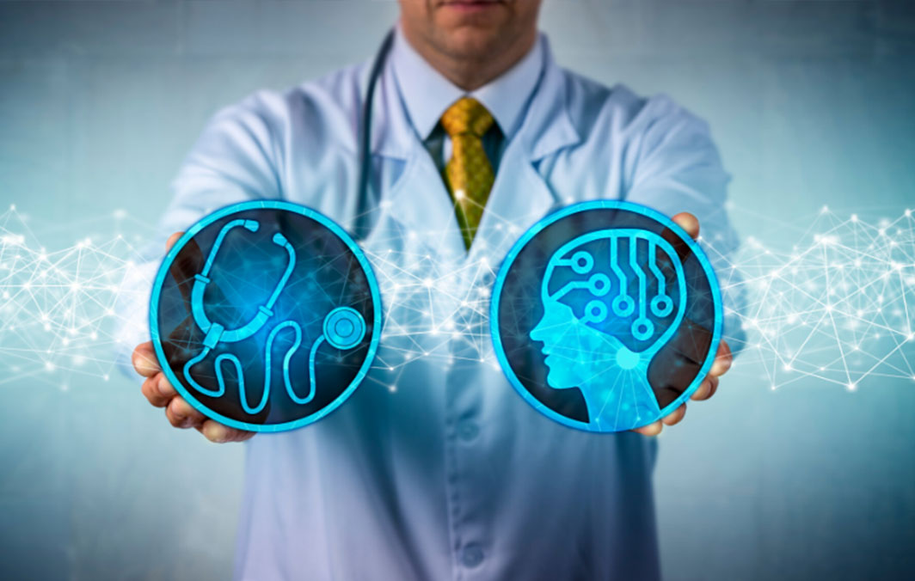
One of the world's highest-growth industries, the AI sector was valued at about $600 million in 2014 and is projected to reach a $150 billion by 2026.


